Design Clinic Scheme
Know about this scheme :-
Related Scheme | Design Clinic Scheme for Design Expertise to MSME manufacturing sector under NMCP Schemes
Description | To bring the MSME sector and design expertise on a common platform and to provide expert advice and solutions on design problems, resulting in continuous improvement and value addition for existing products. It also aims at value added cost effective solutions.
Nature of assistance | Financial assistance given to MSMEs for design development.
Who can apply? | All MSMEs with EM registration.
Download Scheme Guidelines
ACHIEVEMENTS SO FAR :-
Objectives of the scheme
Design Clinic Scheme for Design Expertise to MSME manufacturing sector.
• To create a sustainable design eco system for the MSME sector through continuous learning and skill development
• Bring the industrial design fraternity closer to the MSME Sector
• Develop an institutional base for the industry’s design requirement;
• Increase the awareness of the value of design and establish design learning in the MSME
• Increase the competitiveness of local products and services through design.
Salient Features
• Applicability of project funding is to an individual MSME or a group of MSMEs coming together.
• A Design Company/ Academic Institutions will visit the unit and scrutinize all designs relevant fields & will suggest next steps to be taken.
• Project Proposal to be prepared and to be submitted to Design Clinic Centre for consideration.
• Mobilization and co-ordination workshop for MSME officials.
• Seminar / Workshops (including need assessment survey).
• Promotional Activities such as Orientation programme for stake holders, Study on Global Practices & Design Clinic Programme of other countries and National Level Workshop, etc.
• Implemented through National Institute of Design (DIPP Institution).
2. Brief major activities taken under the scheme
The scheme is divided in two major parts:
i. Design Awareness- Seminars & Workshop Design Seminars:
One day seminar covering design related topics to sensitize MSME’s about the usage of design in various facets of their industry. (GOI contribution Rs. 60,000/- per programme).
Design Workshop
• Total time allocated for each workshop is 3 - 5 days.
• One day will be spent in visiting Cluster & understanding issues concerned with cluster. Thereafter there will be training on design clinic solution delivered by an expert or a group of experts in an interactive manner. (GOI contribution Rs. 3.75 lakh per programme).
ii. Design Projects – Professional Design Projects & Students Design Projects
Professional Design:
To facilitate MSMEs to develop new Design strategies and or design related products and services through project interventions and consultancy. (GoI contribution @ 75% for micro, 60% for SMEs for the project range Rs. 15 lakh to Rs. 40 lakh.)
Students Design Projects:
Students in the final year under UG/PG programmes from institutions recognized by design clinic centre are eligible under this activities for the project work done for respective MSMEs. (GOI contribution @ 75% for the project cost of Rs. 2 lakh)
Performance :
S.No. | Year | No. of MSME benefited | Actual Expenditure (in Crore)
1 | 2009-10 to 2011-12 | 9986 | 15.36
2 | 2012-13 | 2077 | 6.70
3 | 2013-14 | 7863 | 7.51
4 | 2014-15 | 5406 | 9.60
5 | 2015-16 | 867 | 0.00
6 | 2016-17 | 0 | 7.18
Total |  | 26199 | 46.35
Flow of Scheme
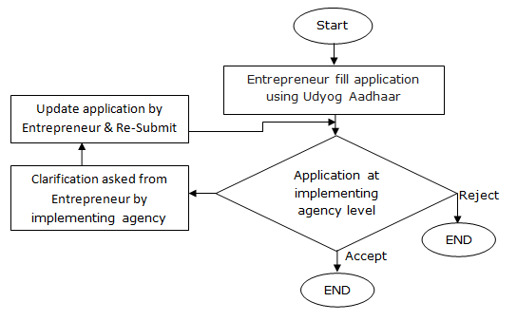
Last updated date : 26/10/2016

